# Preguntas Objetivo 4

## Pregunta 1

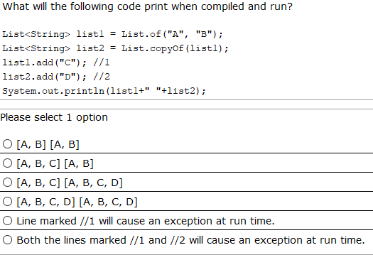

## Pregunta 2

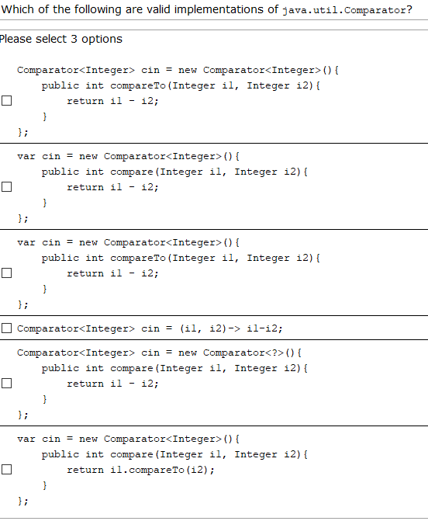

## Pregunta 3

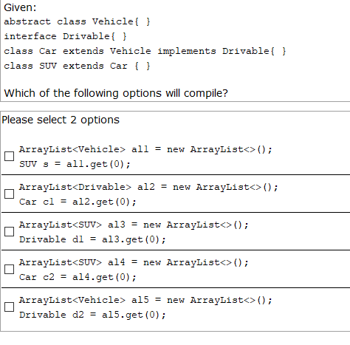

## Pregunta 4

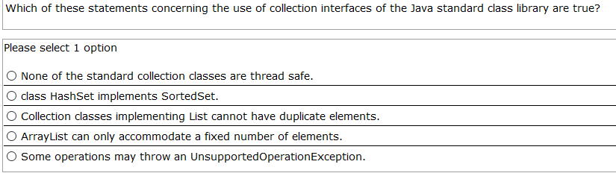

## Pregunta 5

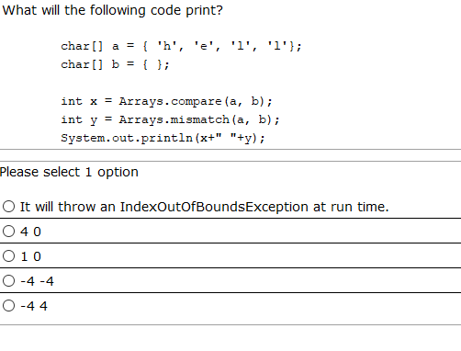

## Pregunta 6

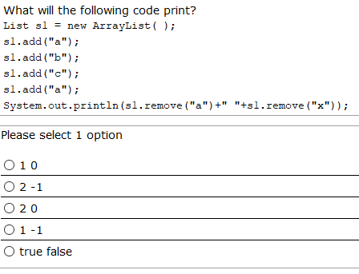

## Pregunta 7

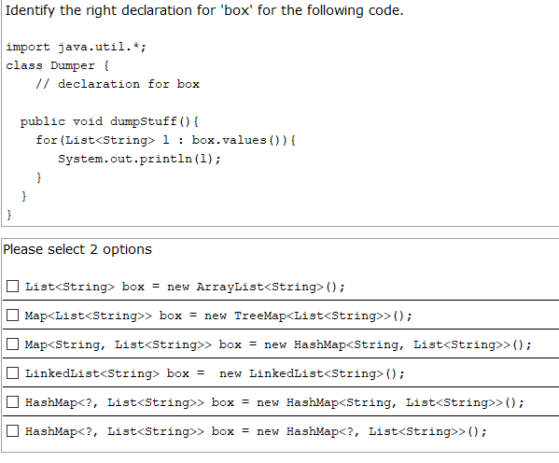

## Pregunta 8

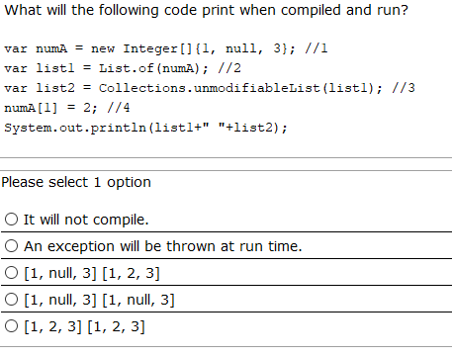

## Pregunta 9

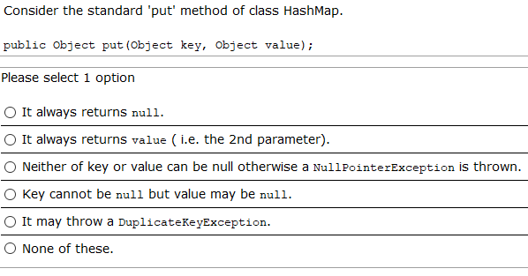

## Pregunta 10

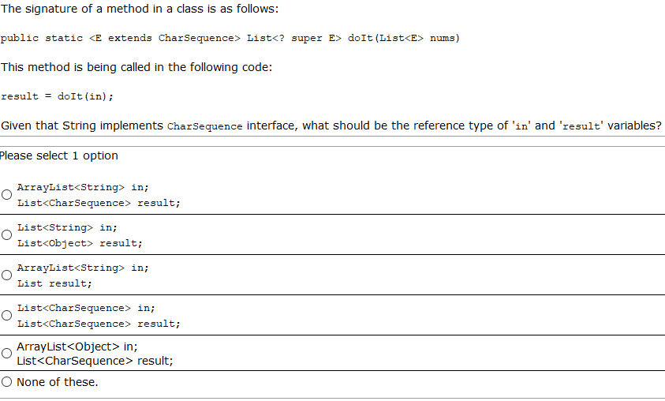

## Pregunta 11

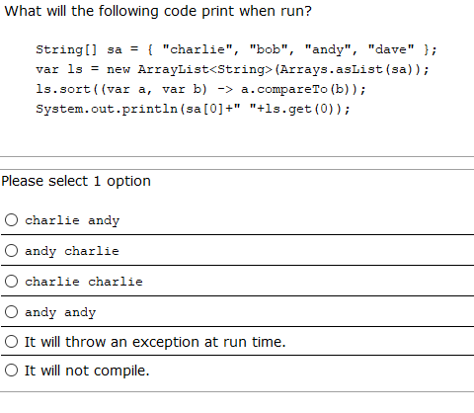

## Pregunta 12

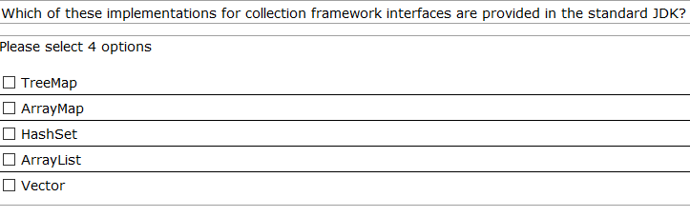

## Pregunta 13

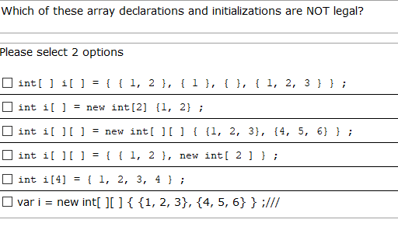

## Pregunta 14

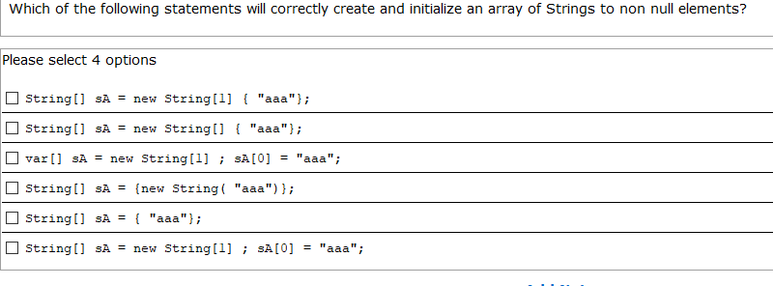

## Pregunta 15

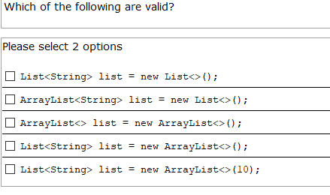

## Pregunta 16

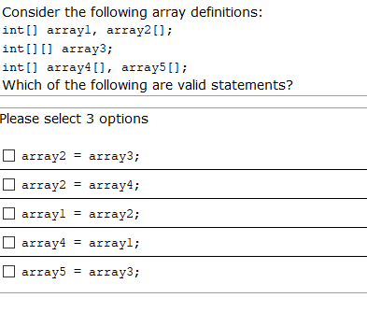

## Pregunta 17

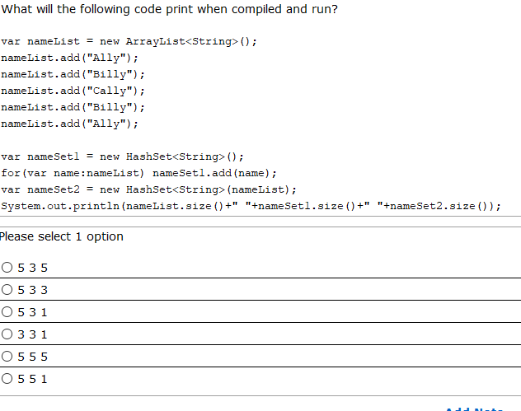

## Pregunta 18

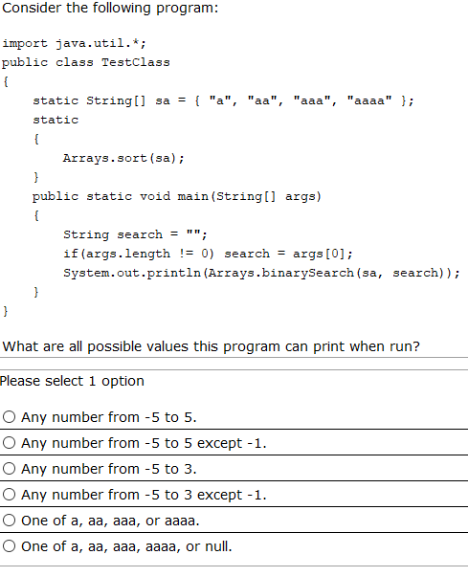

## Pregunta 19

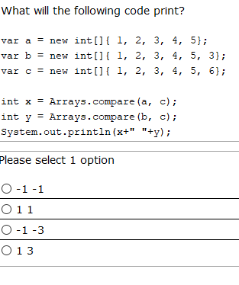

## Pregunta 20

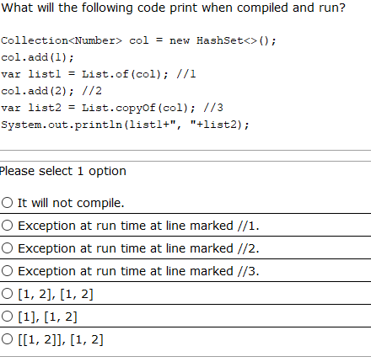

# Pregunta 21

Given:

**public** **void** printLength(/*here*/, Integer data) {

list.add(data);

System.***out***.println(list.size());

}

Which of the following declaration parameter in /*here*/ makes the method printLength compile correctly? (choose 2)

1. List<?> list
2. List<? extends Number> list
3. List<? extends Integer> list
4. List<? super Number> list
5. List< Number> list

# Pregunta 22

Consider the following code:

import java.util.*;

class Book{ }

class TextBook extends Book{ }

class BookList extends ArrayList<Book>

{

public int count = 0;

public boolean add(Object o)

{

if(o instanceof Book b) return super.add(b);

else return count++ == -1;

}

}

//in valid context

BookList list = new BookList();

list.add(new Book());

list.add(new TextBook());

list.add("hello");

System.out.println(list.count);

What will it print?

1. 0
2. 1
3. 2
4. It will not compile because the add method does not correctly override the add method from ArrayList
5. It will not compile because on incorrect usage of instanceof

# Pregunta 23

Select the correct sentences (choose 3):

A . Iterable<Integer> it=List.of(4,9,1);

B. var data=new ArrayList<>();

C. Collection<?> values=List.of(9,2,5);

D. List<Object> objs=new ArrayList<Integer>();

E. List<Integer> ints=new Integer[] {4,1,0};

F. ArrayList<String> cads=List.of("year","now");

# Pregunta 24

What will the following code print?

List s1 = new ArrayList( );

s1.add("a");

s1.add("b");

s1.add("c");

s1.add("a");

if(s1.remove("a")){

if(s1.remove("a")){

s1.remove("b");

}else{

s1.remove("c");

}

}

System.out.println(s1);

1. [b]
2. [c]
3. [b,c,a]
4. [a,b,c,a]
5. Exception at runtime